Part I. Paper Assignment

1. Determine the system function, magnitude response, and phase response of the following systems and use the pole-zero pattern to explain the shape of their magnitude response:

$y\left[n\right]=\frac{1}{4}\left(x\left[n\right]+x\left[n-1\right]\right)-\frac{1}{4}(x\left[n-2\right]+x[n-3])$

System function: $H\left(z\right)=\frac{Y\left(z\right)}{X(z)}=\frac{1}{4}\left(1+z^{-1}-z^{-2}-z^{-3}\right)=\frac{1}{4}\left(1-z^{-1}\right){\left(1+z^{-1}\right)}^{2}$

* Zero: 1, -1; Pole: 0

$z=e^{jω}=cos(ω)+jsin(ω)$

$H\left(e^{jω}\right)=0.25[\left(1+cos\left(ω\right)-cos\left(2ω\right)-cos\left(3ω\right)\right)+j(-sin\left(ω\right)+sin\left(2ω\right)+sin\left(3ω\right))]$

* Magnitude response: $\left|H\left(e^{jω}\right)\right|$

$\left|H\left(e^{jω}\right)\right|=0.25\sqrt{{\left(1+cos\left(ω\right)-cos\left(2ω\right)-cos\left(3ω\right)\right)}^{2}+{\left(-sin\left(ω\right)+sin\left(2ω\right)+sin\left(3ω\right)\right)}^{2}}$

* Phase response: $∠H\left(e^{jω}\right)=\frac{-sin\left(ω\right)+sin\left(2ω\right)+sin\left(3ω\right)}{1+cos\left(ω\right)-cos\left(2ω\right)-cos\left(3ω\right)}$

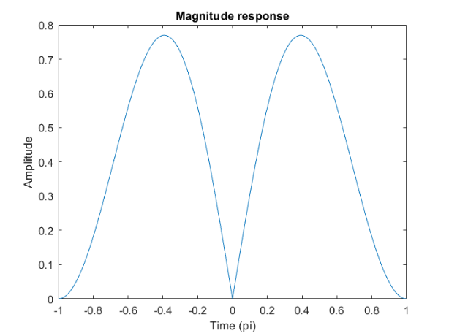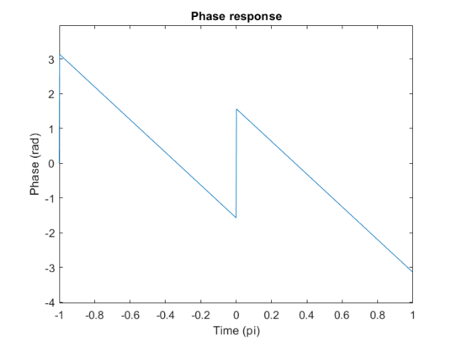

* Pole-zero pattern:

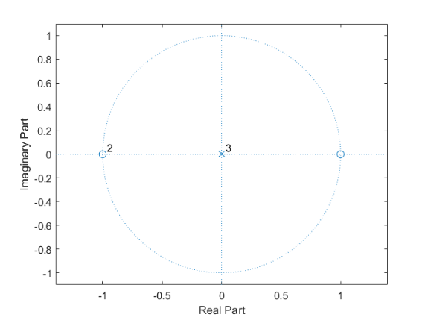

由pole-zero pattern我們可以推測magnitude response在 $±π$ 處會是0，因為zero的緣故。

$y[n]=x[n]-x[n-4]+0.6561y[n-4]$

System function: 🡺 Zero: $±$ 1, $±$ j; Pole: $±$ 0.9, $±$ 0.9j

$H\left(e^{jω}\right)=\frac{\left(1-\cos\left(4ω\right)\right)-j\sin{(4ω)}}{\left(1-0.6561cos\left(4ω\right)\right)-0.6561j\sin{(4ω)}}$

Magnitude response: $\left|H\left(e^{jω}\right)\right|$； Phase response: $∠H\left(e^{jω}\right)$

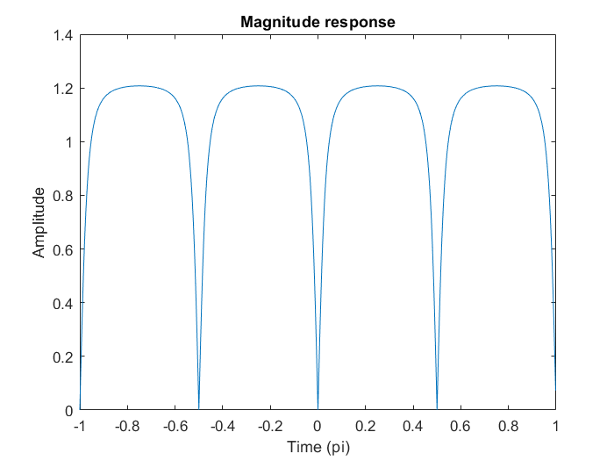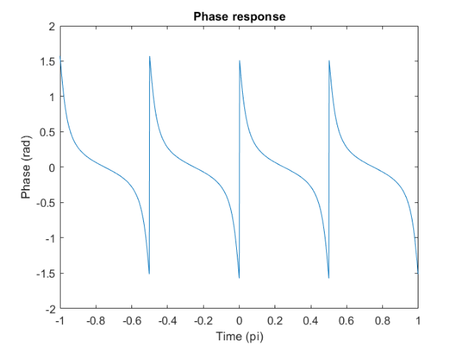

Pole-zero pattern:

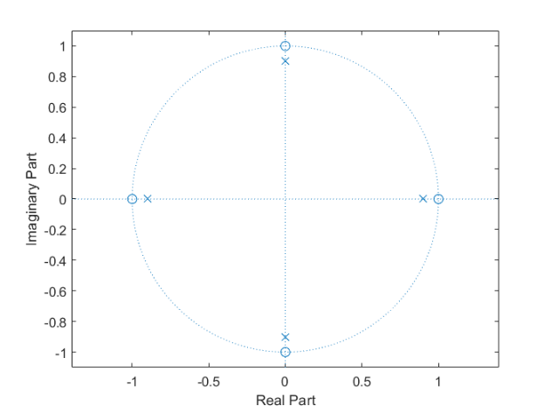

由pole-zero pattern我們可以推測magnitude response在 $±1, ±j$ 處會是0，因為zero的緣故。再加上在zero附近皆存在一個pole，因此magnitude response的rising time和falling time會比1(a)來的小。

1. Consider a periodic signal

$x\left[n\right]=\sin\left(0.1πn\right)+\frac{1}{3}\sin\left(0.3πn\right)+\frac{1}{5}sin⁡(0.5πn)$.

For each of the following systems, determine if the system imparts (i) no distortion, (ii) magnitude distortion, and/or (iii) phase (or delay) distortion.

$h\left[n\right]=\{1_{n=0}, -2, 3, -4, 0 ,4, -3, 2, -1\}$

$H\left(z\right)=\sum_{n=-∞}^{+∞}{h\left[n\right]z^{-n}}=1-2z^{-1}+3z^{-2}-4z^{-3}+4z^{-5}-3z^{-6}+2z^{-7}-z^{-8}$

$⇒\left|H(e^{jω})\right|≠constant, ∠H\left(e^{jω}\right)≠-ωn_{d}$

$⇒$ This system not only imparts magnitude but also phase distortion.

$y\left[n\right]=10x\left[n-10\right]$

$H\left(e^{jω}\right)=10e^{-j10ω}$ $⇒\left|H(e^{jω})\right|=10=constant, ∠H\left(e^{jω}\right)=-10ω$

$⇒$ This system imparts no distortion.

1. An economical way to compensate for the droop distortion in S/H DAC is to use an appropriate digital compensation filter prior to DAC.
2. Determine the frequency response of such an ideal digital filter $H_{r}\left(e^{jω}\right)$ that will perform an equivalent filtering given by following $H_{r}(jΩ)$

$$H_{r}\left(jΩ\right)=\left\{\begin{aligned}\frac{ΩT/2}{sin⁡(ΩT/2)}e^{jΩT/2}, \left|Ω\right|<π/T \\ 0, otherwise\end{aligned}\right.$$

$X_{c}\left(jΩ\right)=\left\{\begin{aligned}T X(e^{jΩT}), \left|Ω\right|<π/T \\ 0, otherwise\end{aligned}\right.↔X\left(e^{jΩT}\right)=\frac{1}{T}\sum_{-∞}^{+∞}{X_{c}[j(Ω-\frac{2π}{T}k)]}$

$H_{r}\left(e^{jΩT}\right)=\frac{1}{T}\frac{ΩT/2}{sin⁡(ΩT/2)}e^{jΩT/2}, \left|Ω\right|<\frac{π}{T}, ω=ΩT$

$H_{r}\left(e^{jω}\right)=\frac{1}{T}\frac{ω/2}{sin⁡(ω/2)}e^{jω/2}, \left|ω\right|<π$

1. One low-order FIR filter suggested in Jackson (1996) is

$$H_{FIR}\left(z\right)=-\frac{1}{16}+\frac{9}{8}z^{-1}-\frac{1}{16}z^{-2}$$

Compare the magnitude response of $H_{FIR}\left(e^{jω}\right)$ with that of $H_{r}\left(e^{jω}\right)$ above.

$z=e^{jω}=cos(ω)+jsin(ω)$

$H_{FIR}\left(e^{jω}\right)=\frac{1}{16}[\left(-1+18cos\left(ω\right)-cos\left(2ω\right)\right)+j(-18\sin\left(ω\right)+\sin{(2ω)})]$

$\left|H_{FIR}\left(e^{jω}\right)\right|=\frac{1}{16}\sqrt{{\left(-1+18cos\left(ω\right)-cos\left(2ω\right)\right)}^{2}+{\left(-18\sin\left(ω\right)+\sin\left(2ω\right)\right)}^{2}}$

$\left|H_{r}\left(e^{jω}\right)\right|=$ $\frac{1}{T}\frac{ω/2}{sin⁡(ω/2)}, \left|ω\right|<π$

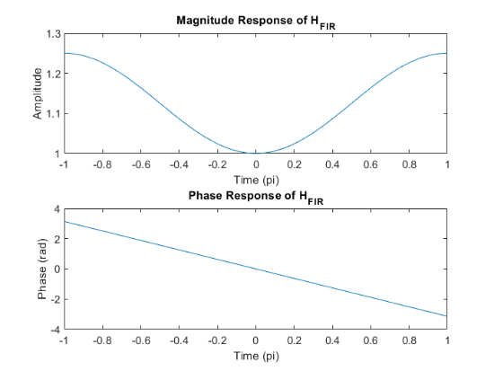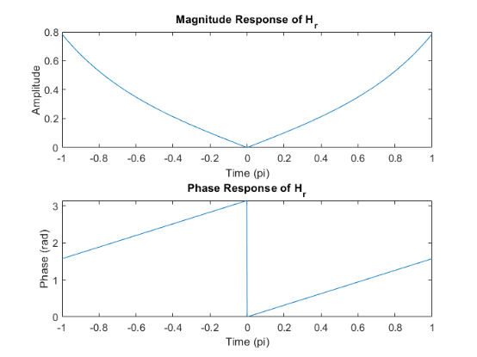

We can the curve of magnitude response of $H_{FIR}\left(e^{jω}\right)$ is smoother and larger than magnitude response of $H_{r}\left(e^{jω}\right)$.

1. Another low-order IIR filter suggested in Jackson (1996) is

$$H_{IIR}\left(z\right)=\frac{9}{8+z^{-1}}$$

Compare the magnitude response of $H_{IIR}\left(e^{jω}\right)$ with that of $H_{r}\left(e^{jω}\right)$ above.

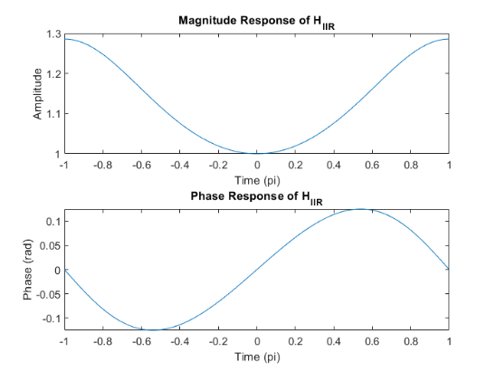

We can the curve of magnitude response of $H_{IIR}\left(e^{jω}\right)$ is smoother and larger than magnitude response of $H_{r}\left(e^{jω}\right)$.

1. Consider the following continuous-time system
$$H\left(s\right)=\frac{s^{4}-6s^{3}+10s^{2}+2s-15}{s^{5}+15s^{4}+100s^{3}+370s^{2}+744s+720}$$

2. Show that the system $H\left(s\right)$ is a nonminimum phase system.

Minimum phase system: All poles and zeros are inside unit circle.

$s^{4}-6s^{3}+10s^{2}+2s-15=(s+1)(s-3)(s^{2}-4s+5)$

$s^{5}+15s^{4}+100s^{3}+370s^{2}+744s+720=(s+5)(s^{2}+4s+8)(s^{2}+6s+18)$

* Zeros: -1, 3, 2 $±$ j & Poles: -5, -3 $±$ 3j, -2 $±$ 2j
* Only one zero is inside unit circle, so this is a nonminimum phase system.

1. Decompose $H\left(s\right)$ into the product of minimum phase component $H_{min}\left(s\right)$ and an all pass component $H_{ap}\left(s\right)$.

$H\left(s\right)=\frac{\left(s+1\right)\left(1-3s\right)\left({5s}^{2}-4s+1\right)}{\left(1+5s\right)\left({8s}^{2}+4s+1\right)\left(18s^{2}+6s+1\right)}×\frac{\left(s-3\right)\left(s^{2}-4s+5\right)\left(1+5s\right)\left({8s}^{2}+4s+1\right)\left(18s^{2}+6s+1\right)}{\left(s+5\right)\left(s^{2}+4s+8\right)\left(s^{2}+6s+18\right)\left(1-3s\right)\left({5s}^{2}-4s+1\right)}$

$=H_{min}\left(s\right)×H_{ap}\left(s\right)$

$H_{min}\left(s\right)=\frac{\left(s+1\right)\left(1-3s\right)\left({5s}^{2}-4s+1\right)}{\left(1+5s\right)\left({8s}^{2}+4s+1\right)\left(18s^{2}+6s+1\right)}$

$H_{ap}\left(s\right)=\frac{\left(s-3\right)\left(s^{2}-4s+5\right)\left(1+5s\right)\left({8s}^{2}+4s+1\right)\left(18s^{2}+6s+1\right)}{\left(s+5\right)\left(s^{2}+4s+8\right)\left(s^{2}+6s+18\right)\left(1-3s\right)\left({5s}^{2}-4s+1\right)}$

1. Briefly plot the magnitude and phase responses of $H\left(s\right)$ and $H_{min}\left(s\right)$ and explain your plots.

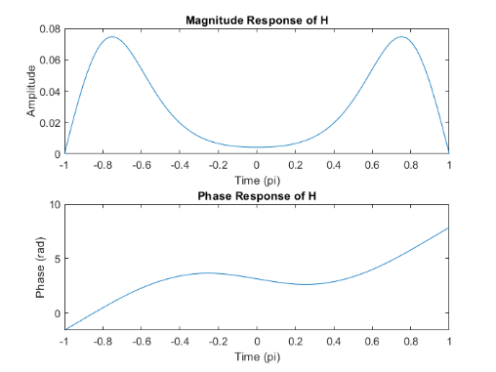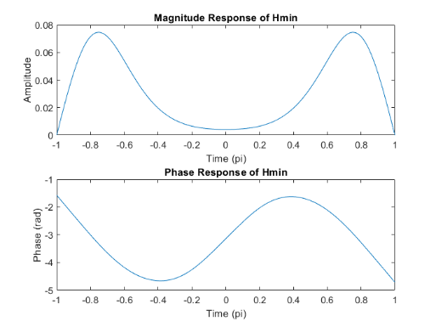

We can find that $\left|H_{min}\left(s\right)\right|=|H\left(s\right)|$ and $∠H_{min}(s)<∠H(s)$

1. Briefly plot the magnitude and phase responses of $H_{ap}\left(s\right)$.

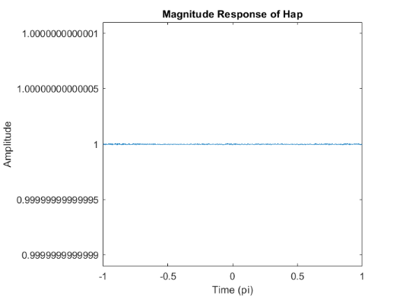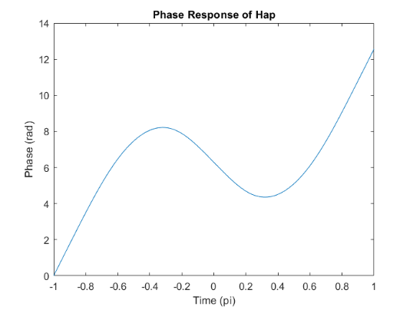

We can find that $\left|H_{ap}\left(s\right)\right|=1$ and $∠H_{ap}\left(s\right)+∠H_{min}\left(s\right)=∠H(s)$

1. We want to design a second order IIR filter using pole-zero placement that satisfies the following requirements: (1) the magnitude response is 0 at $ω_{1}=0$ and $ω_{3}=π$ (2) The maximum magnitude is 1 at $ω_{2,4}=±π/4$ and (3) the magnitude response is approximately $1/\sqrt{2}$ at frequencies $ω_{2,4}±0.05$. Determine locations of two poles and two zeros of the required filter and then compute its system function H(z).

Zero: $±$ 1; Pole: 0.74 $±$ 0.74j $⟹H\left(z\right)=\frac{1}{18}\frac{1-Z^{-2}}{1-1.49z^{-1}+1.11z^{-2}}$

1. Briefly graph the magnitude response of the filter. 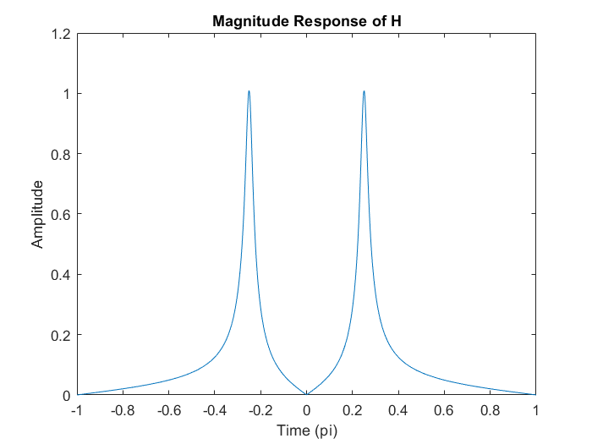
2. Briefly graph phase and group-delay responses.

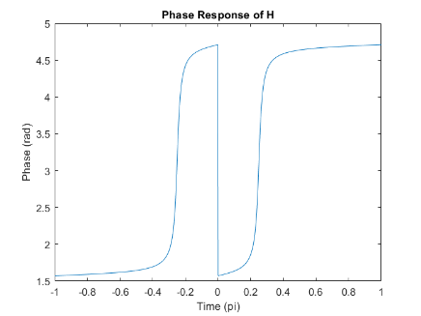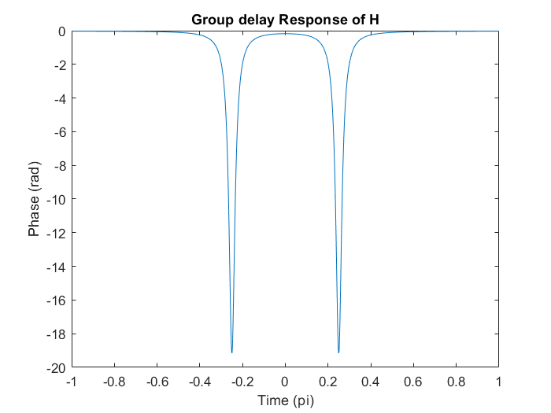

1. The following signals $x_{c}\left(t\right)$ is sampled periodically to obtain the discrete-time signal $x\left[n\right]$. For each of the given sampling rates in $F_{S}$ Hz or in T period, (i) determine the spectrum $X\left(e^{jω}\right)$ of $x\left[n\right]$; (ii) plot its magnitude and phase as a function of ω in $rad/sam$ and as a function of F in Hz; and (iii) explain whether $x_{c}\left(t\right)$ can be recovered from $x[n]$.
2. $x_{c}\left(t\right)=5e^{j40t}+3e^{-j70t}$, with sampling period $T=0.01, 0.04, 0.1$

$e^{jω_{0}n}↔2πδ\left(ω-ω_{0}\right),\sin\left(ω_{0}n\right)=\frac{π}{j}[δ\left(ω-ω_{0}\right)-δ\left(ω+ω_{0}\right)]$

$x\left[n\right]=x_{c}\left(nT\right)⟶X\left(e^{jω}\right)=2π[5δ\left(ω-40πT\right)+3δ\left(ω+70πT\right)]$

1. For T = 0.01s

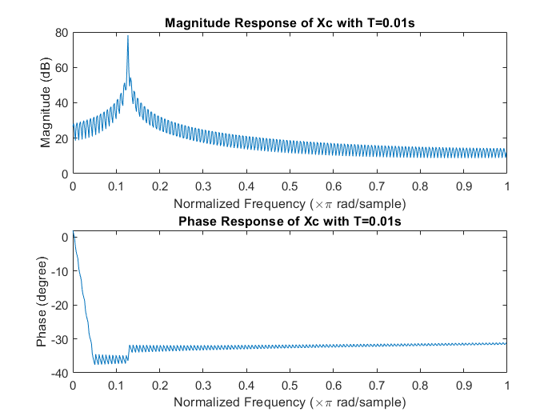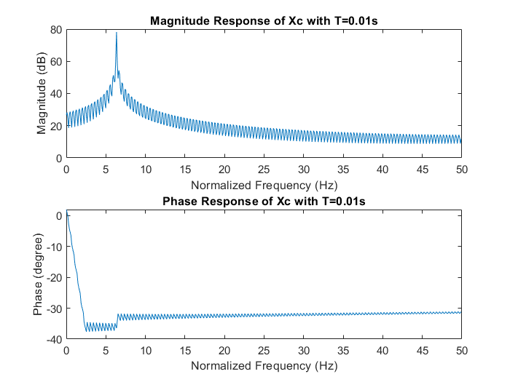

1. For T = 0.04s

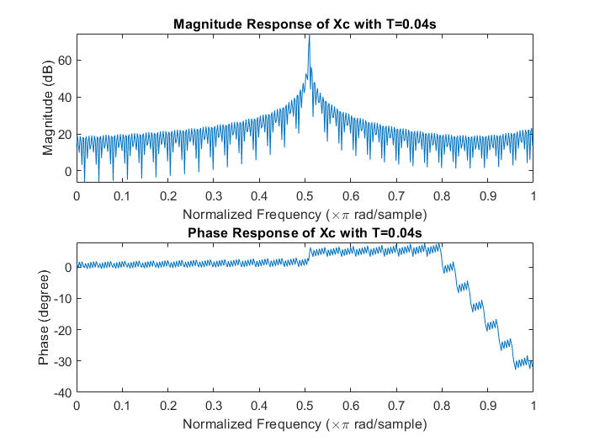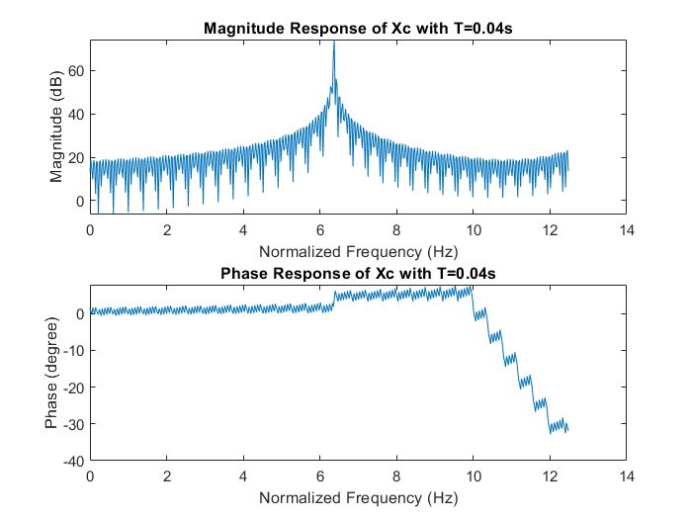

1. For T = 0.1s

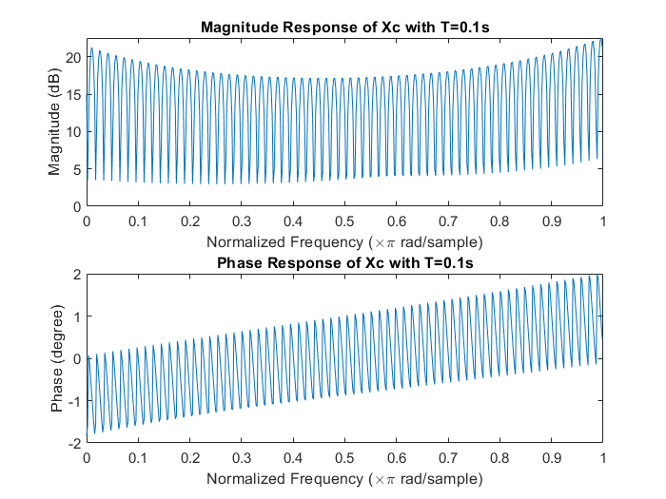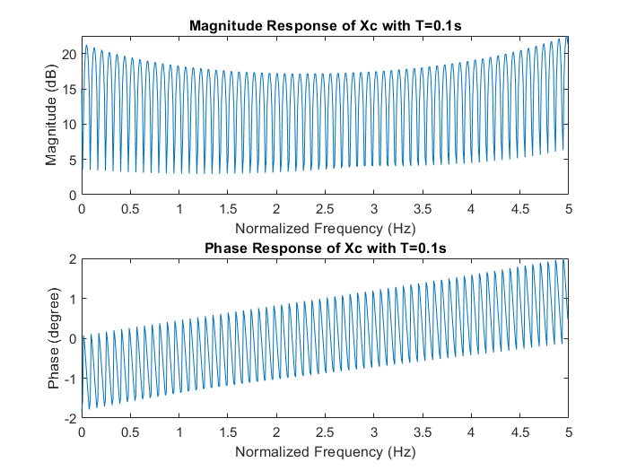

The sampling theorem shows that sampling signal can be recovered if $T_{H}≥2×T$, which $T_{H}$ is $π$/35 s, which equal to 0.089s, in the signal $x_{c}(t)$.

Therefore, the sampling signals with $T=0.01s$ and $0.04s$ can be recovered.

1. $x_{c}\left(t\right)=3+2\sin\left(16πt\right)+10cos⁡(24πt)$, with sampling rate $F_{S}=30, 20, 15 Hz$.

$x\left[n\right]=x_{c}\left(nT\right), T=F_{S}^{-1}$

$X\left(e^{jω}\right)=6πδ(ω)+\frac{5π}{j}\left[δ\left(ω-\frac{16π}{F_{S}}\right)-δ\left(ω+\frac{16π}{F_{S}}\right)\right]+10π[δ\left(ω-\frac{24π}{F_{S}}\right)+δ\left(ω+\frac{24π}{F_{S}}\right)]$

1. For $F_{S}=30Hz$

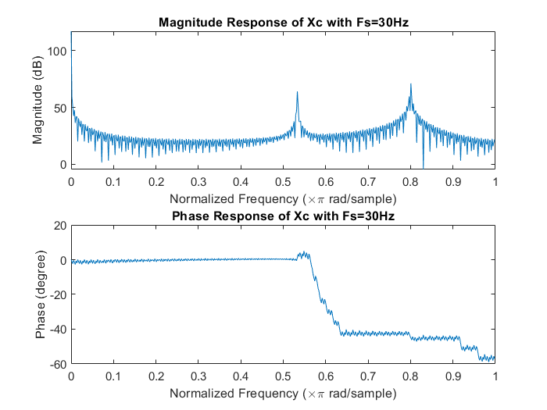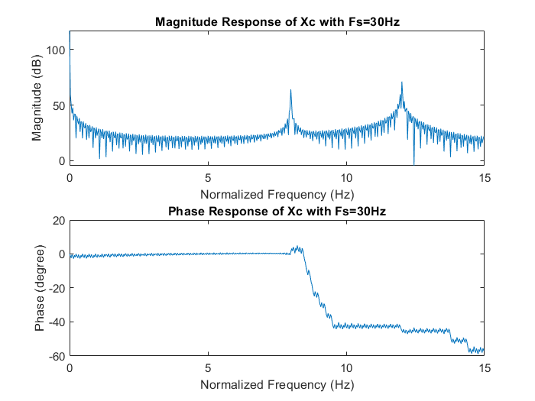

1. For $F_{S}=20Hz$

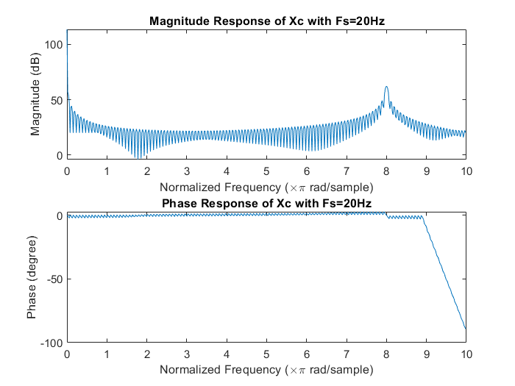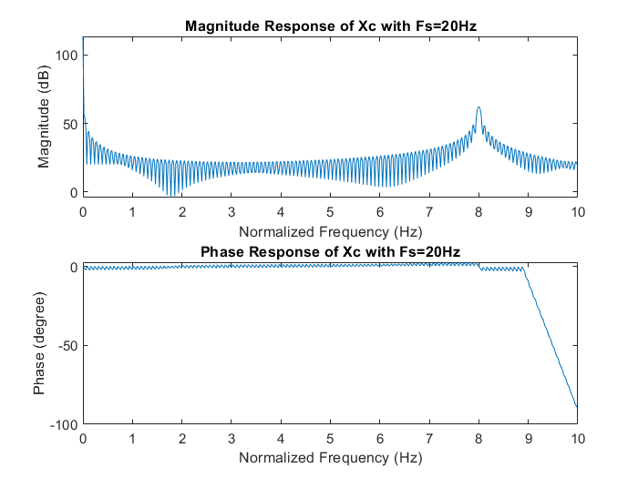

1. For $F_{S}=15Hz$

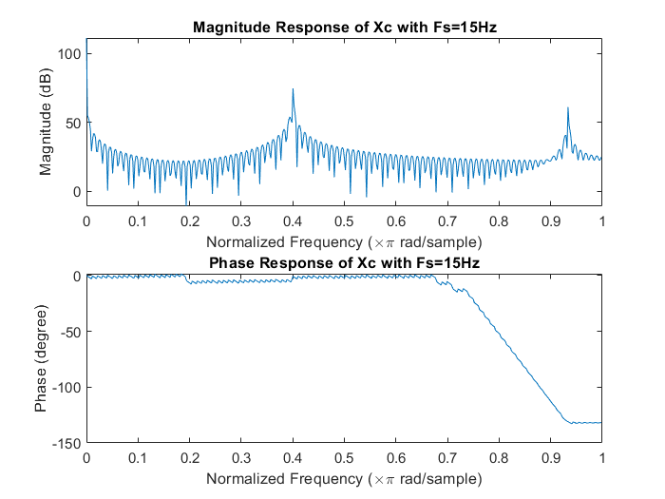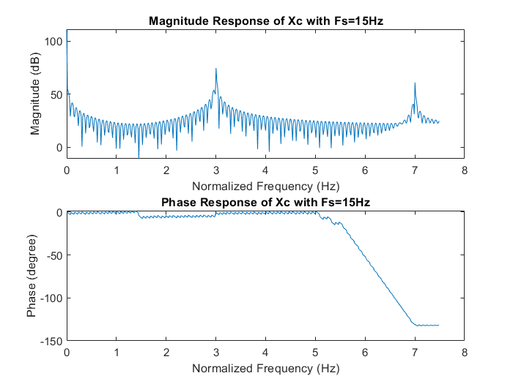

The sampling theorem shows that sampling signal can be recovered if $F_{S}≥2×F_{H}$, which $F_{H}$ is 12Hz in the signal $x_{c}(t)$.

Therefore, only the sampling signal with $F_{S}=30 Hz$ can be recovered.

1. An 8-bit ADC has an input analog range of ±5 volts. The analog input signal is

$$x_{c}\left(t\right)=2\cos\left(200πt\right)+3sin⁡(500πt)$$

The converter supplies data to a computer at a rate of 2048 bits/s. The computer, without processing, supplies these data to an ideal DAC to form the reconstructed signal $y_{c}(t)$. Determine:

1. The quantizer resolution (or step).

$B$ = 8, $Δ=\left(5V-\left(-5V\right)\right)/2^{8}=39m$

The quantizer step ($Δ$) is $39m$ V.

1. The SQNR in dB.

$SQNR\left(dB\right)=10\log_{10}{SQNR}=6.02B+1.76=49.92 dB$

1. The folding frequency and the Nyquist rate.
2. Folding frequency ( = 0.5 Sampling Frequency )

(2048 bits/s)/(8-bit/sample) = 256 samples/s

Sampling Rate = 256-bit/sample $⇒$ Folding frequency = 128 Hz

1. Nyquist rate ( = $2Ω_{H} (rad/sec)$)

$F_{H}=\max\left(100Hz, 250Hz\right)=250Hz$

$⇒Ω_{H}=250×(2π)=1570.8⇒$ Nyquist rate $=3141.6 (rad/sec)$